DESIGN TABLES FOR PRODUCT AND CATEGORY ENTITIES.
Project Title: Payment Transaction Management System

Project Title : Payment Transaction Management System
Student Name : Tamil raj M
Register Number : C4S38022
Department : B.Sc Artificial Intelligence
Course : Artificial intelligence (AI)
Academic Year : 2024 – 2027

1. Create Payment Table
CREATE TABLE Payment (
payment_id INT PRIMARY KEY AUTO_INCREMENT,
customer_id INT,
amount DECIMAL(10,2),
payment_mode VARCHAR(50),
payment_date DATE,
payment_status VARCHAR(20)
);

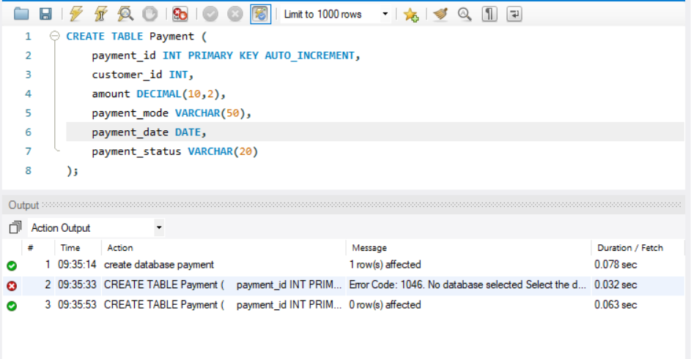

2. Insert Payment Details
INSERT INTO Payment
(customer_id, amount, payment_mode, payment_date, payment_status)
VALUES
(101, 2500.00, 'UPI', '2026-08-20', 'Success'),
(102, 1500.00, 'Credit Card', '2026-08-20', 'Success'),
(103, 3000.00, 'Debit Card', '2026-08-19', 'Failed'),
(104, 1200.00, 'UPI', '2026-08-19', 'Success'),
(105, 5000.00, 'Net Banking', '2026-08-18', 'Failed');

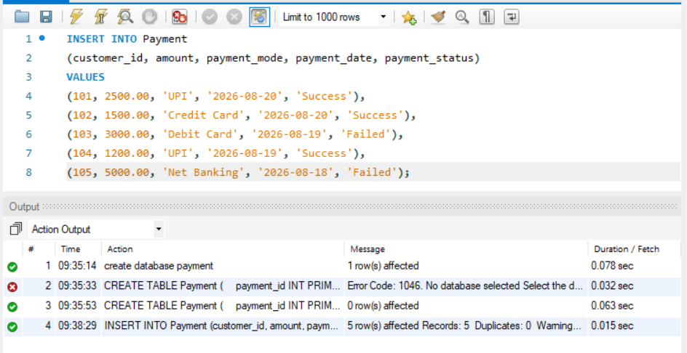

3. Manage Successful and Failed Transactions
Display successful transactions:
SELECT * FROM Payment
WHERE payment_status = 'Success';

Display failed transactions:
SELECT * FROM Payment
WHERE payment_status = 'Failed';
Update a failed payment to successful:
UPDATE Payment
SET payment_status = 'Success'
WHERE payment_id = 3;

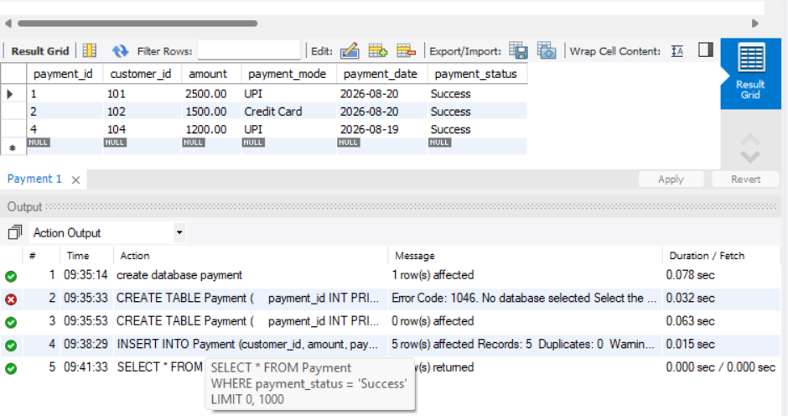

4. Analyze Payment Methods Used by Customers
Count transactions by payment mode:

SELECT payment_mode, COUNT(*) AS total_transactions
FROM Payment
GROUP BY payment_mode;

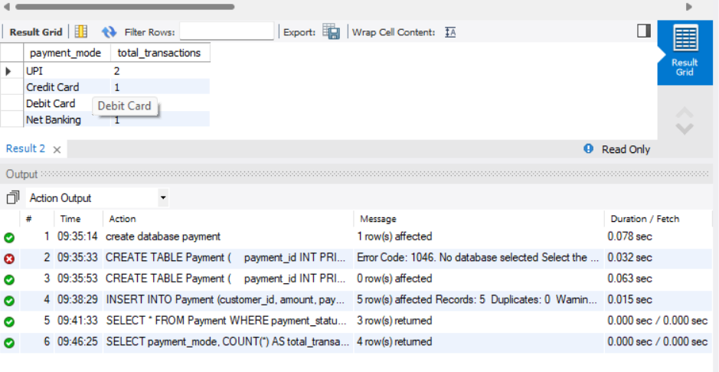

5. Generate Payment Transaction Reports
Complete payment report:

SELECT
payment_id,
customer_id,
amount,
payment_mode,
payment_date,
payment_status
FROM Payment
ORDER BY payment_date DESC;

